Loading Screen – CASS LOGO ([Fathom Producers // Festival Haus | Music Festival Producers](https://fathompro.com/))

Header – CASS Logo

Buttons – Who We Are, Agenda, Speakers, Sponsors, Investment, Contact Us, Register

Section 1 – 35th INTERNATIONAL CA STDUENTS’ CONFERNECE (background 3 picture slide show)

Buttons – Previous Conference, Registration Button, Who We Are ([Circles Conference 2021: A creative design conference in Texas](https://circlesconference.com/))

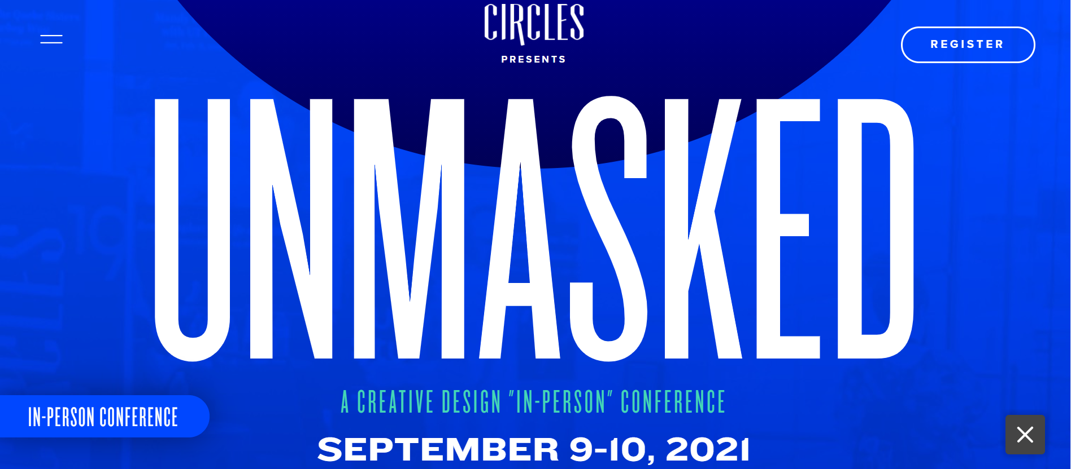

Countdown Widget &Dynamic Arrow ([Creamfields 2021 |](https://www.creamfields.com/))

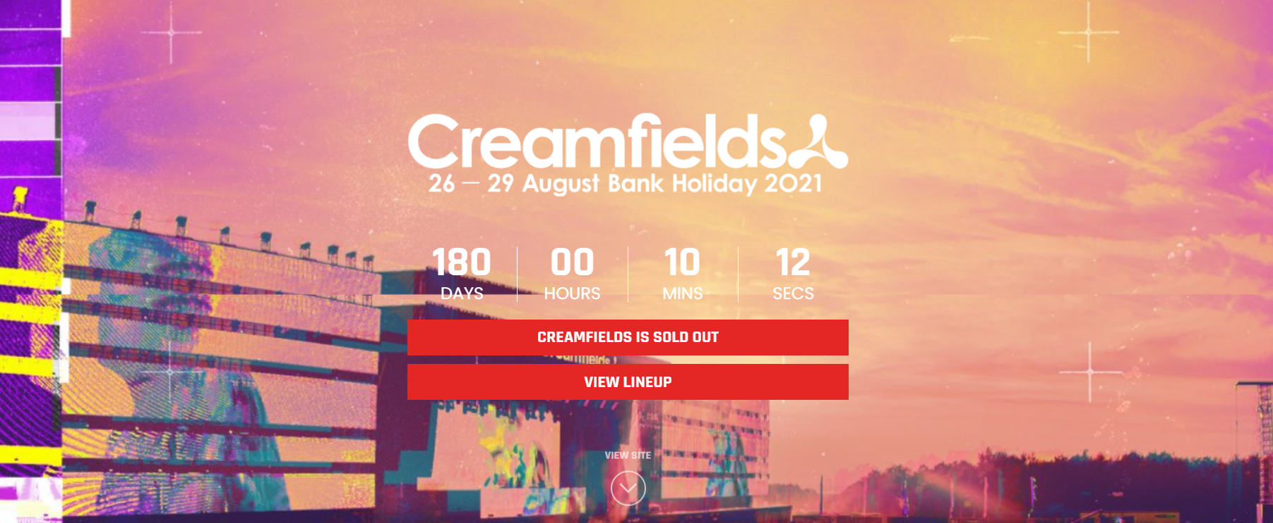

Section 2– Why You Should Join ([Circles Conference 2021: A creative design conference in Texas](https://circlesconference.com/))

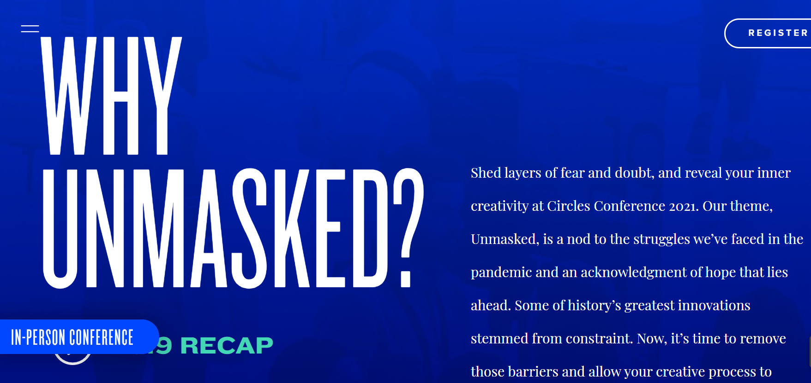

3 Speakers, 2 Panels, 3 Entertainment Items, 1 Business Magazine, 1 Raffle Draw ([Circles Conference 2021: A creative design conference in Texas](https://circlesconference.com/))

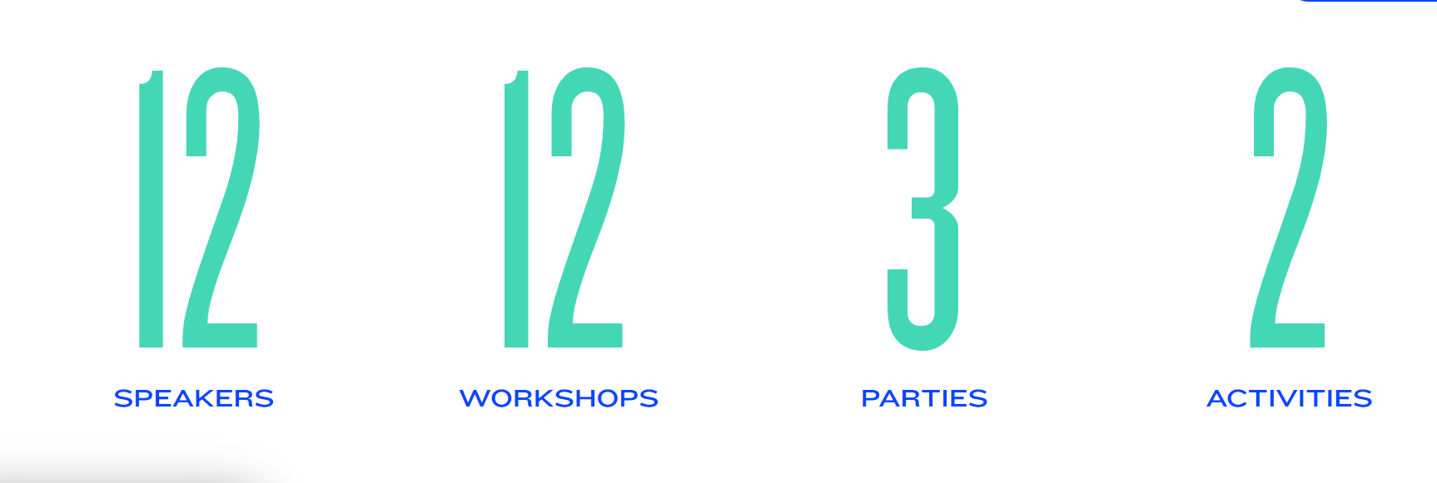

Section 3 – Messages

CA President

CA Vice President

CA CEO

Patron

CASS President

CASS Vice President

CASS General Secretary

CASS Education Secretary

Section 4– How to Join

Video – link will be given

Buttons – Register Now

Section 5 – Who we are

Section 6 – Our Vision & Mission (Together)

Section 7 – Previous Conference Recap (Name + logo)

Section 8 – Theme Video

Video – link will be given

Section 9 – Speakers (Zoom On images)

Section 10 – Gallery

Section 11 – Foreign Delegates Messages

Section 12– Previous Sponsors logos

Section 13 – New Agenda

Section 14– Investment(left) & Register Now (center) & Calender(Right)

Section 15 – Contact us and form box ([Blockchain Nation Conference and Community. Network. Learn. Become More. (bcnation.com)](https://www.bcnation.com/)

(FB, Insta, WA, Youtube)

